**Akshay Lavhaji Patil** 

**Roll No.:** 6102

**Subject:** Big Data Analytics

**Assignment No. 1:** Case Study on Big Data Life Cycle

**M.E. Data Science**

***Abstract* — This case study explores Tesla’s use of Big Data in developing its Full Self-Driving (FSD) system. Tesla collects vast amounts of real-time data from vehicle sensors and cameras, which are ingested, stored, and processed using distributed systems. This data trains machine learning models that improve autonomous driving through continuous updates. Key challenges include handling data at scale and ensuring privacy, while opportunities lie in advancing autonomous driving and optimizing energy solutions. Big Data is critical to Tesla’s strategy for innovation in transportation and energy.**

***Keywords* — Big Data, autonomous driving, Full Self-Driving (FSD), machine learning, data ingestion, real-time processing, fleet learning, Tesla.**

Tesla, the renowned electric car manufacturer, is changing the face of the automobile industry with its advanced self-driving cars. Tesla’s vehicles are equipped with state-of-the-art hardware and software, including an extensive network of sensors and cameras, which allow them to navigate roads, traffic, and other obstacles with remarkable precision.

However, the key to Tesla’s self-driving technology is the vast amounts of data collected from its cars. Through real-time sensors, the cars gather data on various aspects of their surroundings, including lane markings, traffic patterns, road conditions, and even weather.

Tesla’s fleet of vehicles generates massive amounts of data every day, which is processed in real-time using advanced machine learning algorithms. These algorithms analyze the data to identify patterns and trends, which enable Tesla’s self-driving cars to learn and improve over time.

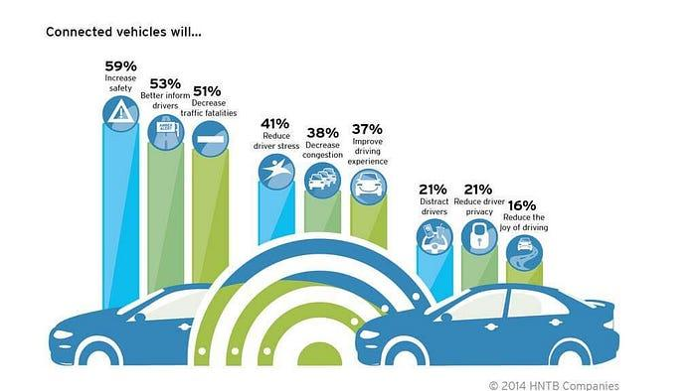

HNTB’s survey made in 2014 of the United States consumers shows people are supportive of the benefits that connected vehicles can bring to the roadsOne of the main sources of data for Tesla’s self-driving technology is the autopilot system. This system is designed to control the car’s speed, acceleration, braking, and steering. By collecting data from the autopilot system, Tesla can improve its self-driving technology’s accuracy and reliability.

Tesla’s use of **Big Data** plays a crucial role in its pursuit of fully autonomous vehicles through the Full Self-Driving (FSD) system. The company's data-centric approach is a key factor in developing, testing, and refining its autonomous driving technology. Here, we delve deeper into Tesla’s Big Data life cycle in the context of supervised FSD development, followed by the associated challenges and opportunities, and conclude with Tesla’s vision for the future.

### *Data Collection: Foundation for FSD*

Tesla’s fleet of vehicles is equipped with an array of sensors—**cameras, radar, ultrasonic sensors**, and **lidar** (earlier models)—that collect huge volumes of data. This data includes:

* **Video feeds**: 360-degree video data from cameras, capturing road conditions, objects, traffic signs, pedestrians, and more.
* **Radar and ultrasonic data**: Provides depth perception and assists in object detection.
* **Driver behavior**: Data on how drivers react in specific driving conditions, critical for training Tesla’s self-driving models.

**In relation to Big Data**:

* The sheer volume, velocity, and variety of the data being collected place Tesla’s data firmly in the Big Data domain.
* Tesla collects data across millions of miles driven globally by its fleet. This requires significant computational power and infrastructure to manage.

### *Data Ingestion: The Challenge of Scale*

Tesla’s vehicles continuously stream data to its data centers. This process involves handling high-frequency data from millions of cars. The ingestion process includes:

* **Real-time data streaming**: Tesla’s system handles real-time data from its vehicles to detect critical events (e.g., near accidents).
* **Edge computing**: Some pre-processing of data is done at the vehicle level (edge computing) to reduce bandwidth usage before sending key data back to Tesla’s cloud systems.

**Big Data aspect**:

* Tesla needs an efficient pipeline for ingesting massive datasets. Technologies like **Apache Kafka** or **Google Cloud Pub/Sub** may be used to handle high-throughput data ingestion.

### *Data Storage: Managing Exabytes of Data*

Given the scale of Tesla's data collection (video, sensor, and telemetry data), Tesla requires massive storage capabilities.

* **Distributed Storage Systems**: Tesla likely uses distributed file systems, such as **Hadoop HDFS**, **Amazon S3**, or its proprietary data lake infrastructure to store raw data from its fleet.
* **Data Lakes**: Tesla stores both structured and unstructured data, allowing data scientists and engineers to access historical datasets for training and testing.

**Big Data relevance**:

* The **variety** of data types (structured, semi-structured, unstructured) coupled with the **volume** of data being stored demands sophisticated distributed storage systems.
* Ensuring high availability and reliability of data storage is critical for continuous development

### *Data Processing: Extracting Insights from Raw Data*

Once data is stored, it must be processed to train and refine Tesla’s FSD algorithms.

* **Batch Processing**: Historical data (e.g., millions of hours of driving footage) is processed to identify patterns and anomalies. Tesla could employ **Apache Spark** for distributed data processing.
* **Stream Processing**: Real-time data (from active vehicles) is processed to improve immediate decision-making. Tesla uses real-time data for tasks like monitoring fleet performance and rapidly deploying updates to its fleet.
* **Labeling Data**: Tesla manually labels a portion of its data to train supervised learning models. For example, video footage is annotated with objects (pedestrians, vehicles, traffic signs) to help Tesla’s neural networks understand the driving environment.

**Big Data relevance**:

* Tesla’s FSD development involves both real-time and historical data analysis. Big Data processing frameworks like **Apache Hadoop** and **Apache Flink** help handle both batch and real-time data.

### *Data Analysis: Developing Full Self-Driving (FSD) Models*

Tesla’s FSD system is based on **supervised learning**. The data collected is used to train models to predict driving behaviors in complex scenarios, such as:

* **Object detection**: Recognizing other vehicles, pedestrians, and road signs.
* **Path planning**: Determining the safest and most efficient route for the vehicle.
* **Behavioral Cloning**: Tesla’s model learns to replicate human drivers’ actions in specific situations based on millions of miles of driving data.

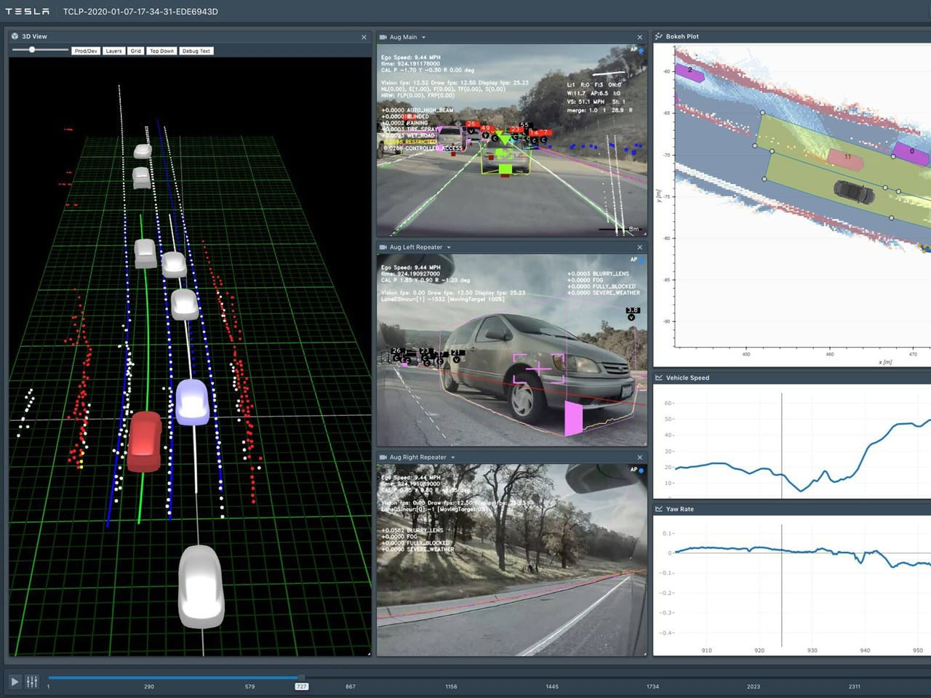

Tesla also uses **simulations** to test its FSD algorithms. Data from real-world driving is used to recreate millions of scenarios, allowing the models to learn how to handle rare or dangerous situations without risk.

**Big Data relevance**:

* **Machine learning** is at the core of Tesla’s FSD development. Training neural networks on such vast datasets requires distributed computing systems and powerful GPUs for deep learning.
* Data analysis involves handling large-scale, multi-dimensional datasets in a highly parallelized environment.

### *Data Visualization and Feedback: Real-Time Monitoring and Updates*

Data visualization is crucial for both development and real-time monitoring. Tesla uses:

* **Internal dashboards**: To monitor fleet performance, detect anomalies, and assess the accuracy of FSD models in different environments.
* **Customer feedback**: Data-driven reports provide insights into vehicle performance, leading to over-the-air (OTA) software updates.

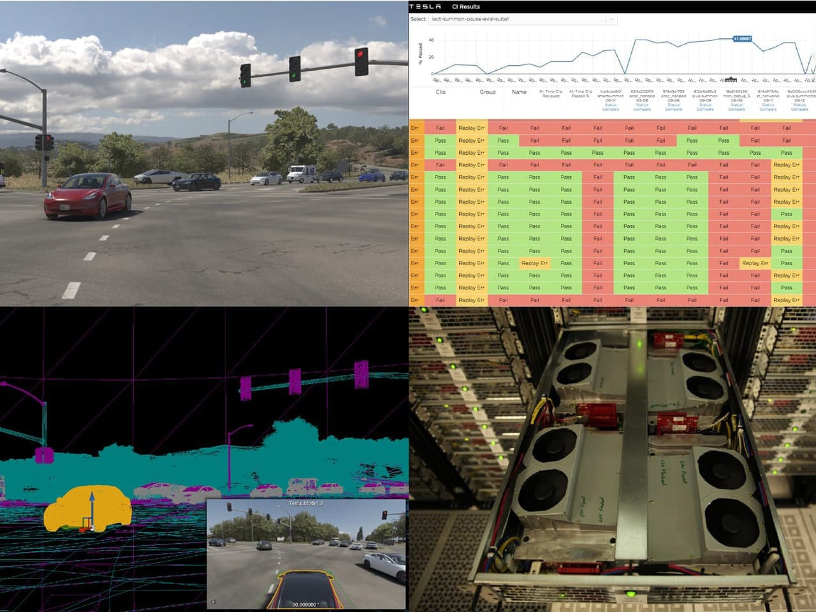

Additionally, Tesla implements **fleet learning**, where updates to FSD algorithms are deployed to its fleet, allowing the system to "learn" from how vehicles interact with the real world.

**Big Data relevance**:

* The continuous feedback loop and real-time updates are only possible due to the vast data streams from millions of vehicles. This requires robust Big Data analytics tools to visualize and act on real-time insights.

### Challenges in Tesla’s Big Data Life Cycle

1. **Data Volume and Scalability**:  
   Tesla’s biggest challenge is the sheer volume of data being collected. Managing petabytes or even exabytes of data efficiently requires cutting-edge data storage, processing, and retrieval technologies.
2. **Data Quality and Labeling**:  
   FSD development requires highly accurate labeled data, and manual labeling at scale is resource-intensive. Tesla has to strike a balance between automated and manual data labeling.
3. **Latency**:  
   Real-time data processing is essential for making immediate decisions in autonomous driving. High-latency systems could impact performance and safety, particularly in real-world driving.
4. **Privacy and Data Security**:  
   Tesla must ensure customer privacy while handling massive amounts of vehicle data. Additionally, securing this data from potential cyber threats is critical.

### Opportunities in Tesla’s Big Data Life Cycle

1. **Autonomous Driving Breakthrough**:  
   With access to large-scale data, Tesla has the opportunity to push the boundaries of fully autonomous driving. The ability to continuously improve the FSD system via machine learning models is key to staying ahead in the autonomous vehicle race.
2. **Energy Optimization**:  
   Tesla can leverage its data capabilities to optimize energy consumption for its solar products and improve battery technology using predictive analytics.
3. **Monetizing Data**:  
   Tesla could explore business opportunities by providing data insights to other industries or cities working on smart transportation systems.

### Conclusion

Tesla’s Big Data life cycle is central to the company’s mission of advancing electric vehicles, autonomous driving, and sustainable energy. The company’s ability to collect, process, and analyze massive amounts of data in real-time has enabled them to make significant progress in the FSD space, as well as in improving their energy products and vehicle manufacturing processes.

The challenges Tesla faces, such as managing the volume and complexity of the data and maintaining data security, are significant but solvable with continued investment in advanced technologies. On the other hand, the opportunities for Tesla to revolutionize autonomous driving and energy solutions using Big Data are immense.

Tesla’s ability to stay agile, iterate quickly, and use data-driven insights will be crucial as it seeks to scale its FSD technology and achieve its vision of a fully autonomous future.

### References

1. Vinay Kumar Moluguri. "Tesla's Applications of Big Data and How It Powers Self-Driven Cars." *Medium*. Available at:<https://vinaykumarmoluguri.medium.com/teslas-applications-of-big-data-and-how-it-powers-self-driven-cars-5c72cc16cf7>
2. Tesla. "Artificial Intelligence at Tesla." *Tesla Official Website*. Available at:<https://www.tesla.com/AI>

**Akshay Lavhaji Patil** 

**Roll No.:** 6102

**Subject:** Big Data Analytics

**Assignment No. 1:** Case study on Business Problems Suited to Big Data Analytics

**M.E. Data Science**

***Abstract—*** **This case study explores how Windy.app leverages Big Data analytics to enhance weather forecasting accuracy. With the help of advanced data collection techniques, such as weather stations, satellites, buoys, and radars, Windy.app gathers vast amounts of data in real-time. This data is processed using sophisticated computational models, including the WRF8 model, and powered by cloud-based supercomputing. By utilizing machine learning algorithms and ensemble modeling, Windy.app improves the precision of short-term and localized forecasts. The case study highlights the challenges of managing large, diverse datasets and the opportunities Big Data presents for improving weather-related decision-making, especially in outdoor activities like sailing, fishing, and paragliding.**

### ***Keywords —* Big Data, weather forecasting, Windy.app, WRF model, machine learning, meteorology, real-time data, supercomputing, ensemble modeling, outdoor activities forecasting.**

### 

#### Introduction

Big Data analytics plays a pivotal role in transforming various industries, and weather forecasting is one of its most profound applications. Windy.app, a professional weather app, leverages Big Data to offer highly accurate weather predictions that are essential for outdoor activities like wind and water sports. This case study examines how Windy.app addresses business challenges by using Big Data to enhance weather forecasting accuracy, ensuring users make informed decisions about their outdoor plans.

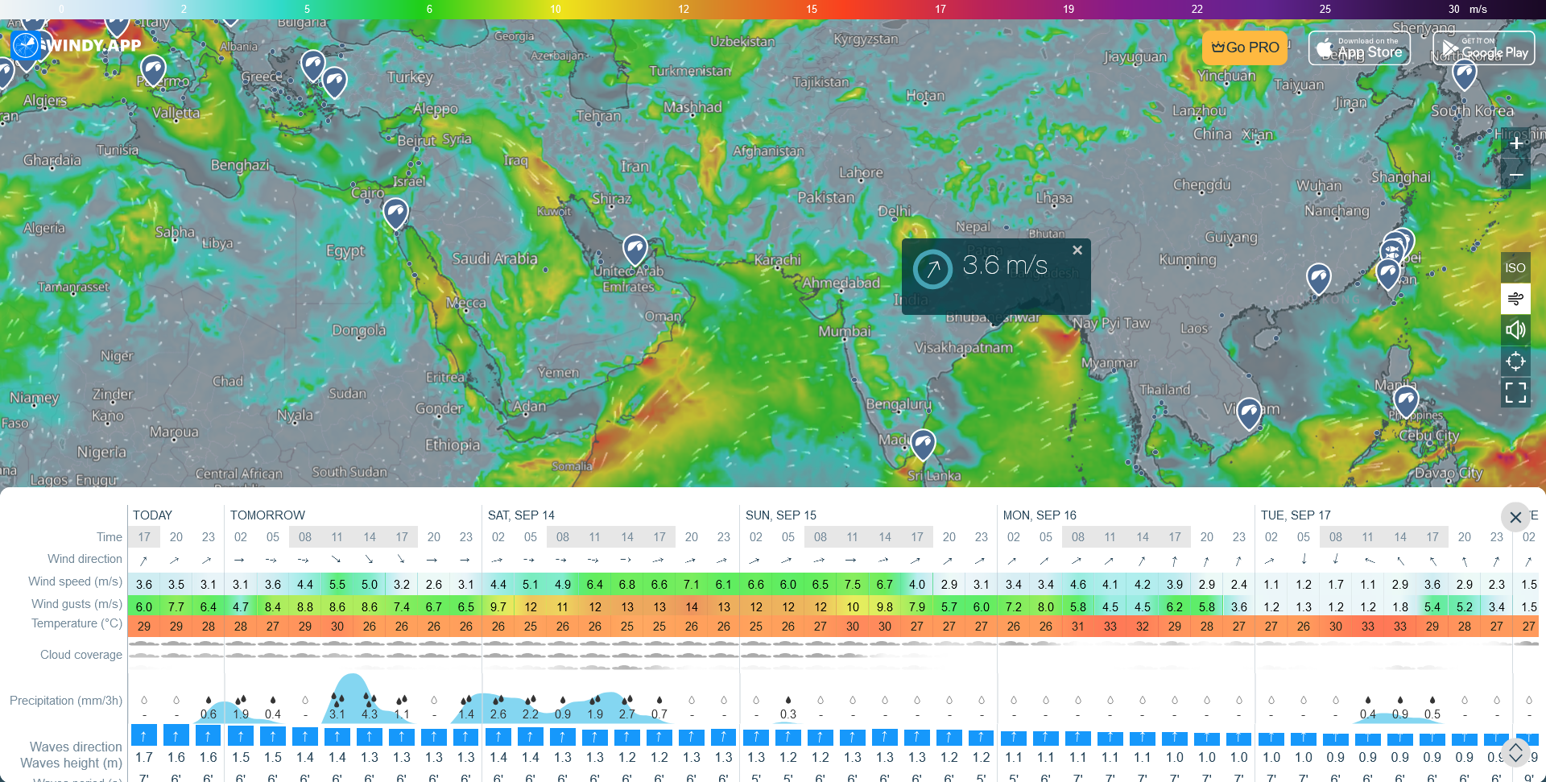

#### The Business Problem

Accurate weather forecasting is crucial for individuals and businesses relying on environmental conditions. Unpredictable weather can result in disrupted activities, lost business opportunities, and increased operational risks. Traditional forecasting methods have limitations due to the complexity of atmospheric data and the sheer volume of information required to predict weather patterns effectively. Windy.app sought to overcome these challenges by integrating Big Data analytics into their weather forecasting model.

#### Big Data in Weather Forecasting

Windy.app employs the 5V model of Big Data—Volume, Velocity, Variety, Veracity, and Value. The app collects vast amounts of data (Volume) from weather stations, satellites, buoys, and radars, generating terabytes of real-time data every day (Velocity). This data comes from various sources (Variety), requiring verification for accuracy (Veracity). The Value lies in providing users with precise weather predictions, directly impacting their decision-making process.

Windy.app aggregates weather data from tens of thousands of global weather stations, NOAA data, and even real-time precipitation information. The data is processed using weather models, such as the WRF-ARM model, which utilizes cloud supercomputing to generate localized and global weather forecasts with high resolution and accuracy.

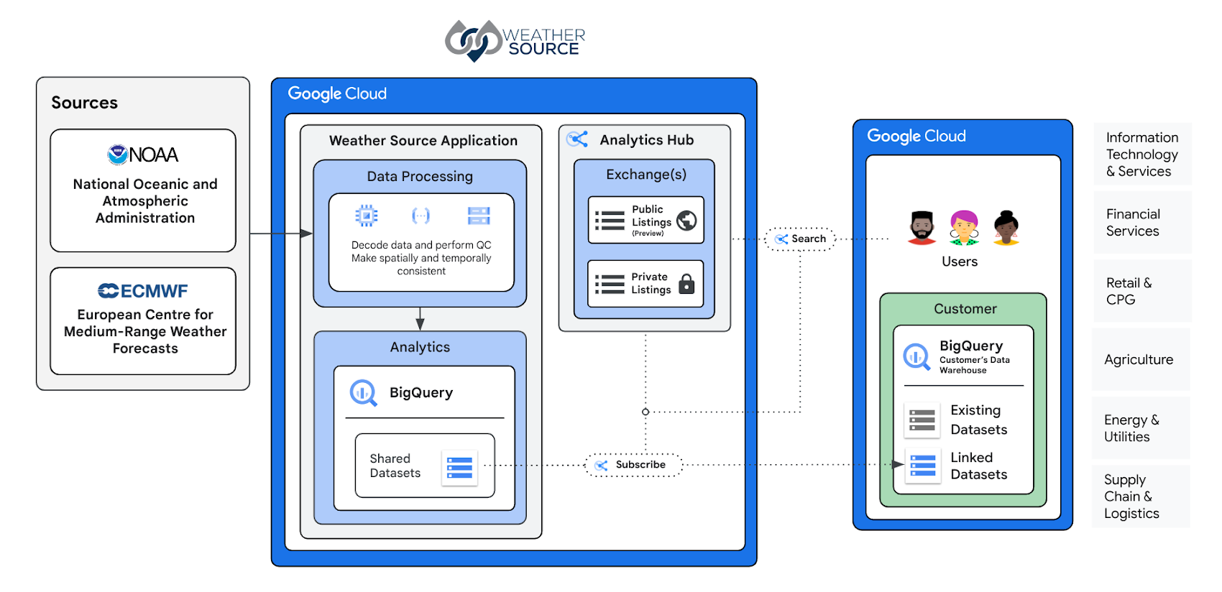

#### Big Data Analytics and Forecast Models

The raw data collected by Windy.app is transformed into actionable insights using computational weather models, which solve complex hydrophysical equations to predict atmospheric behavior. The forecasts are stored as large binary files, containing hundreds of variables, which are processed by the app to display weather conditions in a user-friendly format.

In addition to its core WRF8 model for Europe and East Asia, Windy.app leverages machine learning and deep learning techniques to further refine its forecasts. Machine learning algorithms identify patterns from previous data to reduce forecast errors and increase the accuracy of predictions. The combination of supercomputing power and Big Data analytics allows Windy.app to deliver forecasts with up to 92% accuracy.

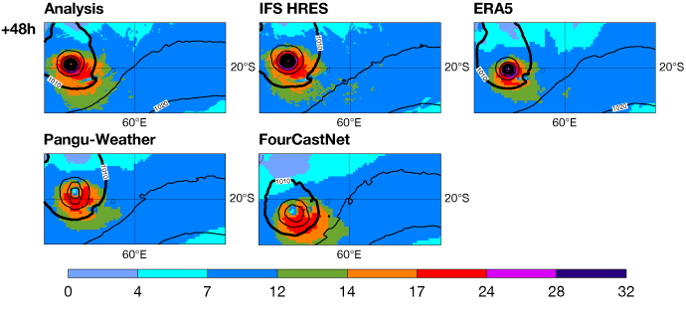

#### Challenges Faced

One of the main challenges Windy.app faces is the complexity of data integration from diverse sources. Processing terabytes of data in real-time requires significant computational power and optimized algorithms. Additionally, weather forecasting is inherently chaotic and uncertain due to the random nature of weather events, making it difficult to achieve 100% accuracy.

Another challenge is the cost of maintaining the high-performance cloud infrastructure required for processing and storing Big Data. The reliance on supercomputers and cloud solutions like Oracle cloud infrastructure adds financial and operational complexity.

#### Opportunities Created by Big Data

Despite these challenges, Big Data offers immense opportunities for Windy.app. By utilizing sophisticated models and vast datasets, the app provides highly localized weather forecasts, which attract a wide user base of outdoor enthusiasts, such as kitesurfers, sailors, and fishermen. The app’s ability to predict extreme weather conditions, such as hurricanes and typhoons, helps protect lives and property, enhancing its reputation as a reliable source for weather information.

Furthermore, Big Data enables Windy.app to continuously improve its forecasting models by using feedback loops that compare predictions with actual outcomes. The insights gained from these comparisons help the app refine its algorithms, ensuring future forecasts are even more accurate.

#### Conclusion

Windy.app's integration of Big Data analytics has revolutionized weather forecasting for its users. The app’s ability to collect, process, and analyze vast amounts of weather data has led to more accurate predictions and has positioned it as a leader in the weather app market. While challenges remain in managing the complexity and cost of Big Data processing, the opportunities created by improved forecasting accuracy far outweigh the difficulties.

By leveraging Big Data, Windy.app not only solves the business problem of unreliable weather predictions but also offers valuable insights to its users, enhancing safety, efficiency, and decision-making for outdoor activities.

#### References

1. Ilya Drigo and Pavel Konstantinov. "How Big Data Analytics Helps in Weather Forecasting: An Example of Windy.app." *Windy.app*. Available at: <https://windy.app/blog/how-big-data-analytics-helps-in-weather-forecasting-an-example-of-windy-app.html>
2. National Oceanic and Atmospheric Administration (NOAA). "How NOAA Uses Big Data to Improve Weather Forecasting." *NOAA.gov*. Available at: <https://www.noaa.gov/education/resource-collections/weather-atmosphere/how-noaa-uses-big-data>

Kind Regards,

**AKSHAY PATIL**

M.E. Data Science (2024-26)

Ph: +91 9673834415

Email: [akshaylavhajipatil_246128@aitpune.edu.in](mailto:akshaylavhajipatil_246128@aitpune.edu.in)  


**Army Institute of Technology,**

Dighi Hills, Pune - 411015

[www.aitpune.com](http://www.aitpune.com)

| Kind Regards,  **AKSHAY PATIL**  M.E. Data Science (2024-26)  Ph: +91 9673834415  Email: [akshaylavhajipatil_246128@aitpune.edu.in](mailto:akshaylavhajipatil_246128@aitpune.edu.in)  **Army Institute of Technology,**  Dighi Hills, Pune - 411015  [www.aitpune.com](http://www.aitpune.com) |
| --- |